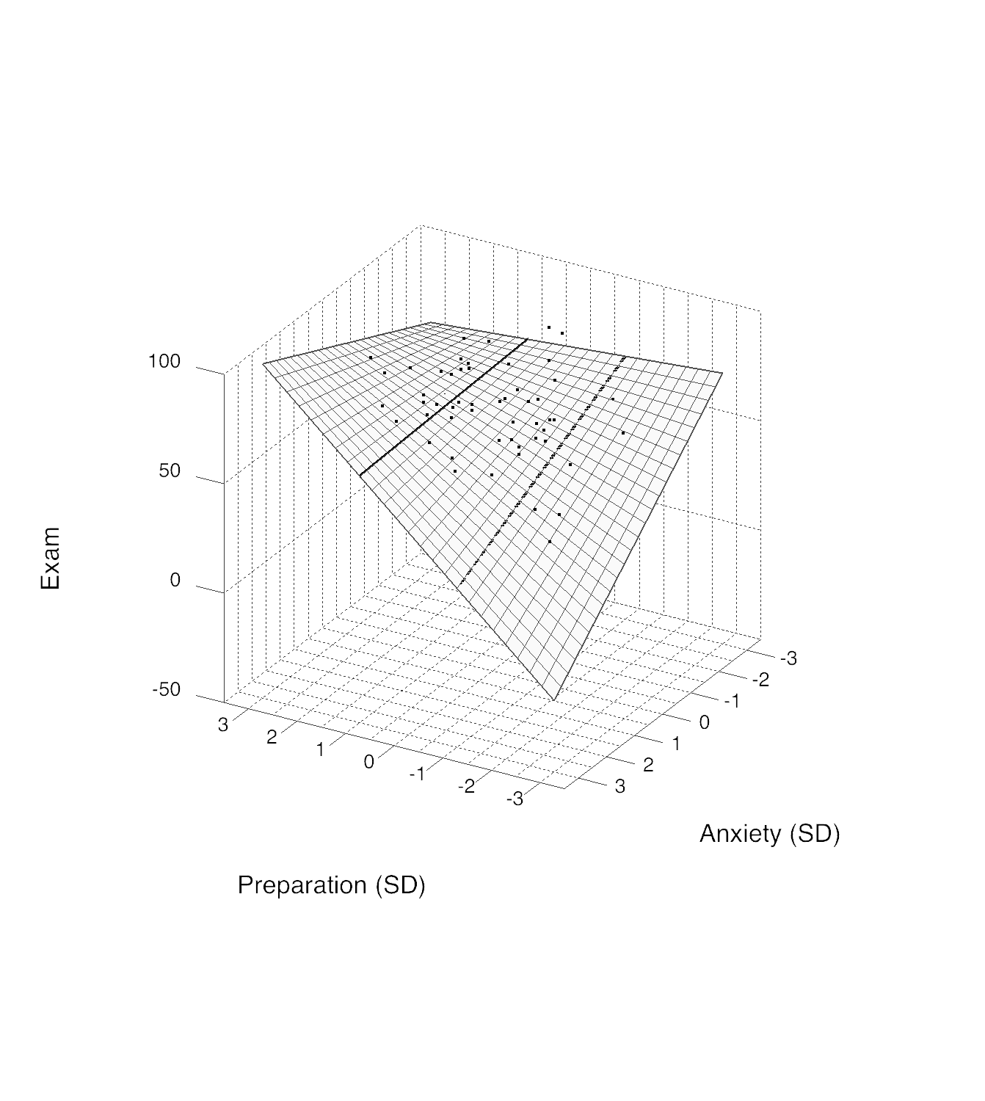

Figure 1. Exam as a function of Anxiety and Preparation. The solid black line on the surface indicates +1 SD Preparation whereas the dashed black line on the surface indicates -1 SD Preparation.

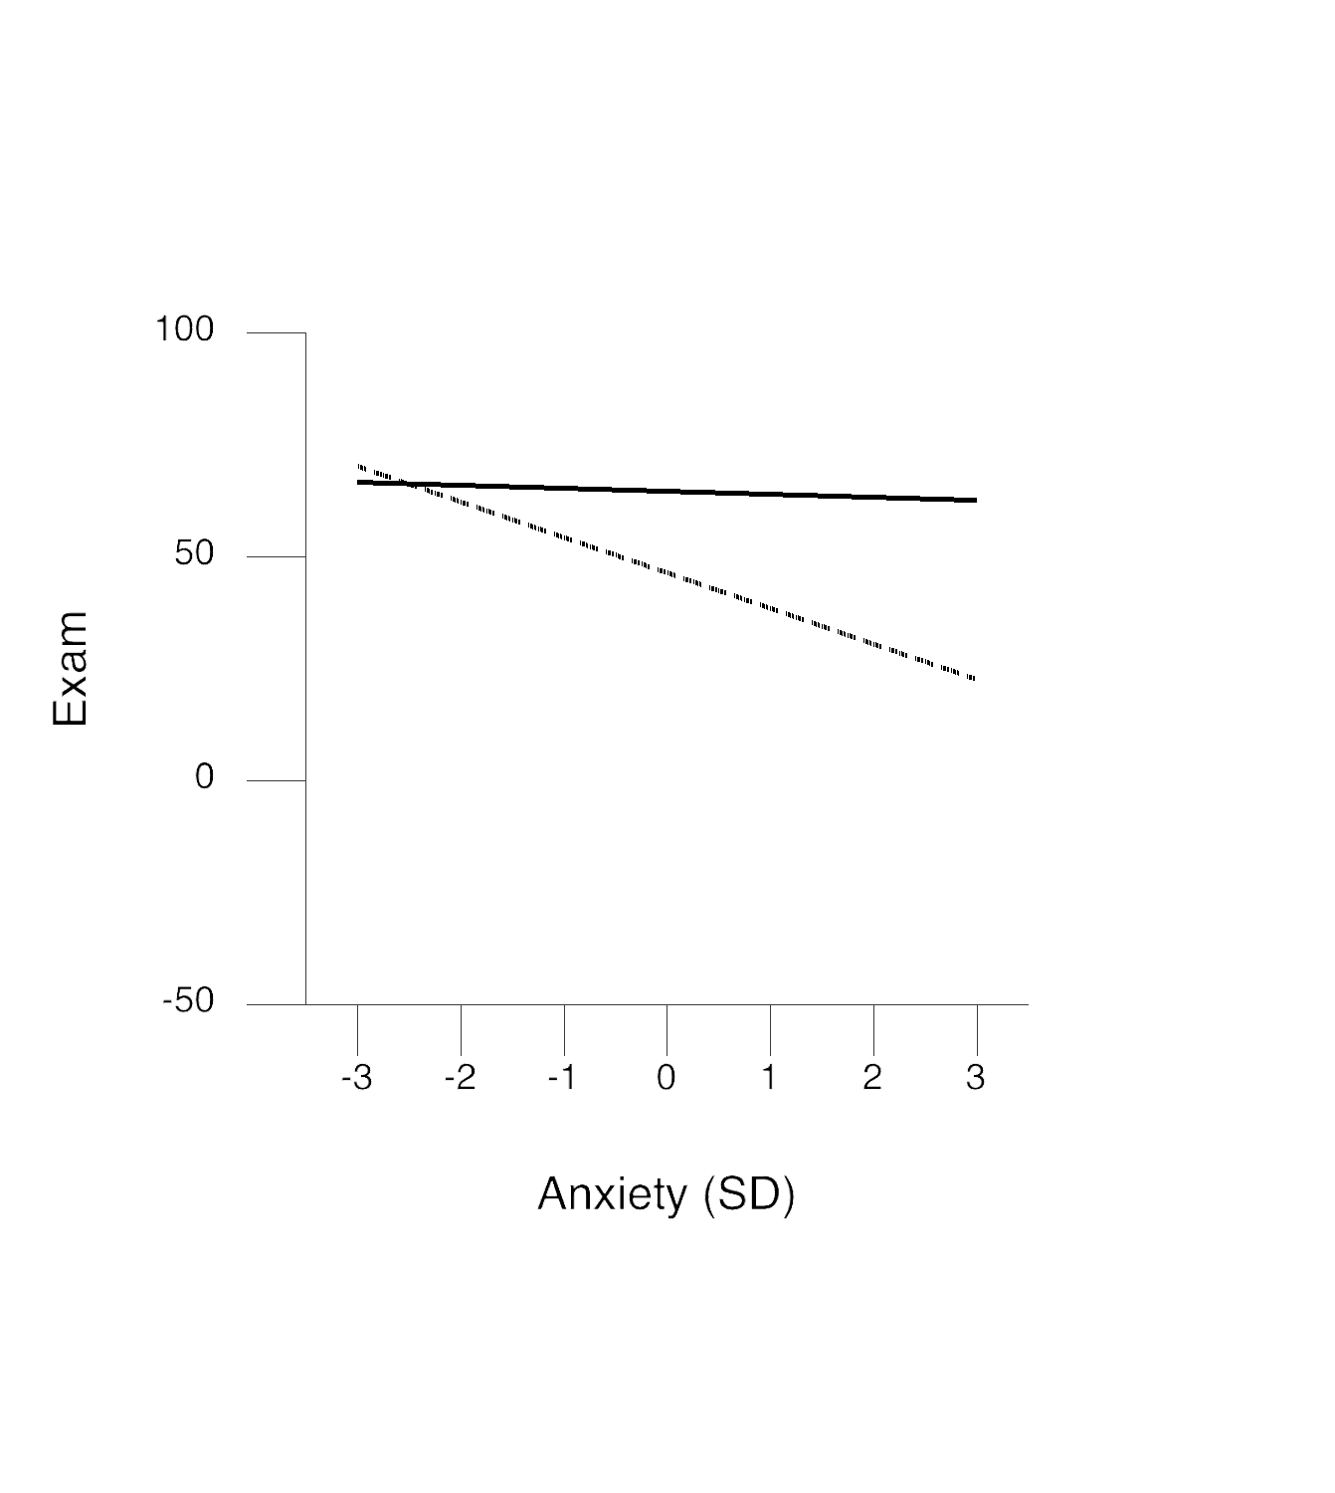

Figure 2. Exam as a function of Anxiety and Preparation. The solid black line indicates +1 SD Preparation whereas the dashed black line indicates -1 SD Preparation.

Model Summary
R | R² | Adjusted R² | F-value | p-value
0.583 | 0.340 | 0.319 | F(3,96)=16.459 | 0.000

variable | b | SE(b) | beta | correct beta | t-value | p-value | sr | sr²
constant | 55.579 | 1.574 |  | 0.000 | 35.313 | 0.000
Anxiety | -2.150 | 0.795 | -0.226 | -0.226 | -2.705 | 0.008 | -0.224 | 0.050
Preparation | 4.565 | 0.795 | 0.479 | 0.479 | 5.740 | 0.000 | 0.476 | 0.227
(Anxiety * Preparation) | 0.908 | 0.416 | 0.183 | 0.190 | 2.180 | 0.032 | 0.181 | 0.033

+1σ Preparation (solid line)
variable | b | SE(b) | t-value | p-value
constant | 64.708 | 2.237 | 28.922 | 0.000
Anxiety | -0.335 | 1.208 | -0.277 | 0.782

-1σ Preparation (dotted line)
variable | b | SE(b) | t-value | p-value
constant | 46.451 | 2.238 | 20.760 | 0.000
Anxiety | -3.966 | 1.092 | -3.633 | 0.000

Notes:

1) b represents the unstandardized regression weight whereas beta represents the standardized regression weight.

2) The 'correct beta' values were calculated as per Cohen, Cohen, West and Aiken (2003) -- who noted that standardized weights must be calculated differently when product terms are involved.

3) sr and sr² represent the semi-partial correlation and the squared semi-partial correlation, respectively. The squared semi-partial correlation (sr²) may be interpreted as the change in R² when this term was added to the regression.

4) All predictors (excluding product terms) were mean centered prior to conducting this analysis. Product terms were constructed from the mean centered predictors.

5) List-wise deletion was used if there was missing data.

Website: www.FastInteraction.com

